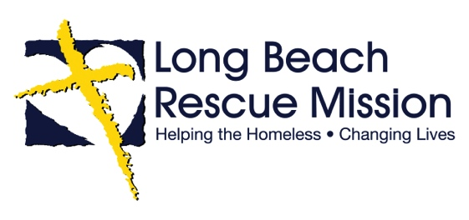

EXECUTIVE DIRECTOR - AD
If you are a Godly leader who is looking for a role of significance, and you have a heart to minister to the homeless, this may be the opportunity for you!

Long Beach Rescue Mission is in search of our next Executive Director. Since our founding in 1971, we have been fortunate to enjoy the support and trust of our community and we have met the needs of countless homeless men, women, and children through emergency relief and long-term residential programming. The Executive Director is responsible to ensure that Long Beach Rescue Mission fulfills its mission and purpose and that we operate and grow in accordance with the Lord’s leading. This role requires spiritual maturity, strategic leadership, excellent relationship skills, integrity, discernment, and execution. Seeking a leader who is passionate about meeting the needs of the homeless in our community and working with others (individuals and agencies) to accomplish excellence and integrity in service. We are a Christ-centered ministry that has set our programs and services on the lasting hope and change that comes through reconciliation and relationship with Jesus Christ.

Long Beach Rescue Mission, located in Los Angeles County, is celebrating 50 years of meeting the needs of the homeless in our community through sharing the transformational love and hope that only Christ offers. We have an annual operating budget of approximately four million dollars. The right candidate will love Jesus and people, be of the highest integrity, demonstrate emotional intelligence, adeptly balance operations, donors, and community, and be able to effectively lead the staff to fulfill our Mission and meet defined goals.

Inquiries, as well as qualified and interested applicants should send their resume to Angie Criner at CareerCrossTraining@gmail.com.

